

STOCKTRACK
(Stock data analyzer and virtualizer using Streamlit)

DESIGN PROJECT - 3 (ECS51803)
Submitted by
DEEKSHITH.A-24CU0310225
ABDUR RAHMAN.A-24CU0310228

MUGUNDHAN.A-24CU0310243

Under the guidance of Mr.V.Jothi Prasad,
Assistant Professor (SG)

in partial fulfillment for the award of the degree of
BACHELOR OF TECHNOLOGY

In
DEPARTMENT OF
COMPUTER SCIENCE AND ENGINEERING



BONAFIDE CERTIFICATE
Certified that this project report STOCKTRACK“Stock Data Analyzer and Virtualizer using Streamlit” is the bonafide work of Deekshith.A(24CU0310225), Abdur Rahman.A(24CU0310228),Mugundhan.A(24CU0310243),who carried out the project work under my supervision during the academic year 2026-2027.
HEAD OF DEPARTMENT | MENTOR
Dr.T.Sudalaimuthu,  Professor and Head,  Department of CSE  INTERNAL EXAMINER | Mr.V.Jothi Prasad,  Assistant Professor(SG),  Department of CSE  EXTERNAL EXAMINER

Project Viva - voce conducted on

TABLE OF CONTENTS
1.ACKNOWLEDGEMENT
2. ABSTRACT
3.LIST OF FIGURES
4.LIST OF ABBREVIATIONS
CHAPTER 1 – INTRODUCTION
Overview
Motivation
Scope of the Project

CHAPTER 2 – LITERATURE REVIEW

Introduction
Evolution of Stock Data systems Existing Technologies

CHAPTER 3 – SYSTEM DESCRIPTION

Introduction
Existing System
Shortcomings of Existing System
Proposed System

CHAPTER 4 – PROJECT REQUIREMENTS

Hardware Requirements
Software Requirements
Tools and Technologies Used

CHAPTER 5 – MODULE DESCRIPTION
Introduction
User Module
Recommendation
Module Summary

CHAPTER 6 – IMPLEMENTATION
Introduction
Hardware Implementation
Software Implementation
Trust Score Algorithm
Module Integration Testing Procedure

CHAPTER 7 – CONCLUSION AND FUTURE WORK

Conclusion
Future Enhancements
CHAPTER 8 - INDIVIDUAL TEAM MEMBERS REPORT

ACKNOWLEDGEMENT

First and foremost, we would like to thank ALMIGHTY GOD, who has provided us with the strength, courage, wisdom, and determination to do justice to our work and contribute our best to it. His blessings and guidance have helped us overcome various challenges and complete our project work successfully.
We wish to express our deep sense of gratitude from the bottom of our hearts to our guide, Mr. V. Jothi Prasad, Assistant Professor (SG), Department of Computer and Science Engineering, for his motivating discussions, overwhelming suggestions, constant support, ingenious encouragement, invaluable supervision, and exemplary guidance throughout this project work. His valuable advice and continuous motivation have helped us improve our knowledge and complete our work with confidence and dedication.
We would like to extend our heartfelt gratitude to Dr.T.Sudalaimuthu, Head of the Department of Computer and Science Engineering, for his valuable suggestions, constant encouragement, guidance, and support in successfully completing the project. We are grateful for her cooperation and for providing us with the necessary motivation to achieve our objectives.
We thank the management of HINDUSTAN INSTITUTE OF TECHNOLOGY AND SCIENCE for providing us with the necessary facilities, infrastructure, resources, and support required for the successful completion of the project. We are also thankful for providing us with a good learning environment and an opportunity to enhance our technical knowledge, practical skills, and overall understanding.
As a final word, we would like to thank each and every individual who has been a source of support, motivation, and encouragement and who has helped us directly or indirectly to achieve our goal and complete our project work successfully. We sincerely appreciate their valuable contributions, cooperation, and assistance throughout the entire project.

ABSTRACT:
The stock market has grown rapidly as an important investment platform for individuals, traders, and financial analysts. However, analyzing stock market data can be challenging because investors often find it difficult to understand stock price movements, market trends, historical performance, and fluctuations in stock prices. Basic observation of stock prices may not provide sufficient insights into market behaviour or help users make informed investment decisions. To address this issue, this project proposes STOCKTRACK, a stock data analyzer and visualizer developed using Streamlit. The system allows users to analyze stock market data and visualize important financial information through an interactive and user-friendly web application. The system provides features such as stock data collection, historical stock price analysis, data preprocessing, statistical analysis, and interactive visualization of stock market trends. The results obtained from these modules are presented using graphical representations such as line charts and other visualizations to help users understand stock price variations, market patterns, and historical performance. The application enables users to explore stock data over different time periods and gain meaningful insights into stock market movements. A final analysis dashboard presents the relevant stock information, trends, and visual reports in an easy-to-understand format. Instead of providing guaranteed predictions or investment recommendations, STOCKTRACK focuses on presenting historical stock data and analytical insights to support better understanding of market behavior. The proposed system is designed to be interactive, accessible, and easy to use, helping users, students, and investors analyze stock market data and make more informed decisions based on the available information.

CHAPTER 1: INTRODUCTION

1.1 Overview
- The stock market plays an important role in the financial world by providing opportunities for individuals and organizations to invest in different companies. With the rapid growth of digital technology, stock market data has become more accessible to investors, students, and researchers. However, understanding stock price movements and analyzing large amounts of market data can be difficult without suitable visualization and analysis tools.
- STOCKTRACK – Stock Data Analyzer and Visualizer Using Streamlit is a web-based application developed using Python and Streamlit to simplify stock market data analysis. The system allows users to explore stock price information, analyze historical trends, and visualize market movements through interactive charts and graphs.
- The application helps users understand important stock market indicators, compare stock performance, and identify patterns in historical data. By presenting complex financial information in a simple and interactive format, STOCKTRACK makes stock market analysis more accessible to beginners, students, and other users interested in financial data.
- The main aim of this project is to provide a user-friendly platform for analyzing and visualizing stock market data without requiring advanced programming or financial analysis skills.

1.2 Scope of the Project
- Stock Data Collection: Retrieve stock market data from a suitable data source.
- Historical Data Analysis: Analyze historical stock prices over selected periods.
- Stock Price Visualization: Display opening, closing, high, and low prices using interactive charts.
- Trend Analysis: Identify general price movements and historical trends.
- Volume Analysis: Visualize trading volume to understand changes in market activity.
- Technical Indicators: Calculate and display indicators such as moving averages, where implemented.

1.3 Organization of Report
The report is organized into ten chapters. Chapter 1 – Introduction explains the project background, motivation, objectives, scope, and organization of the report. Chapter 2 – Literature Review discusses existing research, techniques, and technologies related to stock market analysis and visualization. Chapter 3 – Existing and Proposed Systems describes the limitations of existing approaches and the features of the proposed STOCKTRACK system. Chapter 4 – System Design and Data Flow presents the system architecture, workflow, and movement of data through the application. Chapter 5 – Hardware and Software Requirements lists the hardware, software, libraries, and tools required for development. Chapter 6 – STOCKTRACK Modules explains the individual modules used for data collection, analysis, visualization, and dashboard interaction. Chapter 7 – Implementation and Integration describes the development and integration of the application using Python, Streamlit, and the required data analysis libraries. Chapter 8 – Testing and Performance Analysis presents the testing procedures, functional results, and performance evaluation of the system. Chapter 9 – Conclusion and Future

Enhancements summarizes the project outcomes and discusses possible improvements for future development. Finally, Chapter 10 – Individual Contributions describes the tasks and responsibilities handled by each project member during the development of STOCKTRACK

1.4Objectives
The main objectives of the STOCKTRACK – Stock Data Analyzer and Visualizer Using Streamlit project are:
- To develop a user-friendly web application for stock market data analysis using Python and Streamlit.
- To collect and display historical stock market data from a suitable data source.
- To analyze stock prices, including opening, closing, highest, and lowest prices.
- To visualize stock market trends using interactive charts and graphs.
- To analyze trading volume and understand changes in market activity.
- To calculate and display technical indicators, such as moving averages, if implemented.

1.5 Conclusion
The STOCKTRACK project provides a simple and interactive platform for analyzing and visualizing stock market data using Python and Streamlit. It helps users explore historical stock prices, understand market trends, and interpret financial information through charts, graphs, and summary statistics. The application reduces the difficulty of analyzing raw stock market data by presenting it in an organized and user-friendly dashboard. It is useful for students, beginners, and individuals who want to learn about stock market movements and historical performance

CHAPTER 2: LITERATURE REVIEW
2.1 Introduction
- The literature review focuses on understanding existing stock market analysis methods, financial data visualization techniques, and technologies used for analyzing historical stock prices. Stock market analysis has evolved from manual calculations and spreadsheet-based analysis to advanced software applications that process large amounts of financial data and present results through interactive charts and dashboards.
- Modern data analysis tools help users examine stock price movements, identify historical trends, compare market performance, and understand trading activity. This chapter discusses the development of stock market analysis systems, the technologies used in the STOCKTRACK project, and the limitations of existing approaches that the proposed system aims to address.
2.2 Evolution of Stock Market Analysis Systems
Manual Stock Market Analysis
- In the early stages, stock market analysis mainly involved manually examining stock prices, financial reports, and market records. This process required considerable time and effort, making it difficult to analyze large amounts of data efficiently.
Spreadsheet-Based Analysis
- With the development of computer technology, spreadsheet applications became popular for organizing stock market data, performing calculations, and creating basic charts. However, analyzing multiple stocks and large datasets could still require considerable manual work.

Software-Based Stock Analysis
- Later, specialized software applications introduced automated calculations, historical price analysis, technical indicators, and graphical representations. These tools helped users examine stock performance more efficiently and reduced the effort required for manual calculations.
Interactive Stock Market Dashboards
- Modern web-based dashboards provide interactive charts, filters, and summary statistics to make financial data easier to understand. Frameworks such as Streamlit allow developers to create data analysis applications using Python, making it possible to build accessible stock market visualization systems.
2.3 Existing Technologies
Python
- Python is the primary programming language used in STOCKTRACK because of its simple syntax and extensive support for data analysis and visualization. Libraries such as Pandas and NumPy help process stock market datasets, perform calculations, and organize historical price information.
Streamlit
- Streamlit is a Python framework used to develop interactive web applications for data science and analytics. It allows STOCKTRACK to present stock information, interactive charts, selection controls, and summary statistics through a user-friendly dashboard without requiring extensive front-end development.
Pandas
- Pandas is a data analysis library that provides data structures and functions for handling tabular information. In STOCKTRACK, it can be used to organize historical stock prices, filter records by date, calculate summary statistics, and prepare data for visualization.

Matplotlib and Plotly
- Matplotlib and Plotly are data visualization libraries used to represent numerical information through graphs and charts. Depending on the implementation, STOCKTRACK can use these libraries to display historical stock prices, price trends, trading volume, and other analytical results.
Stock Market Data Sources
- Stock market data sources provide information such as opening price, closing price, highest price, lowest price, and trading volume. STOCKTRACK can use a suitable data provider or historical dataset to retrieve this information for analysis and visualization.

2.4 Conclusion
This chapter reviewed the evolution of stock market analysis systems and the technologies commonly used for financial data processing and visualization. Traditional manual methods and spreadsheet-based approaches can require significant effort when analyzing large amounts of stock market data. Modern tools such as Python, Pandas, Streamlit, and visualization libraries provide an effective way to organize, analyze, and present financial information. Based on these technologies, the STOCKTRACK project aims to develop a simple and interactive stock data analysis application that helps users explore historical prices, visualize market trends, and understand stock performance through an organized dashboard. The review provides the foundation for the system design and implementation discussed in the following chapters.

CHAPTER 3: SYSTEM DESCRIPTION

3.1 Introduction
STOCKTRACK is designed as a web-based application that analyzes and visualizes stock market data using Python and Streamlit. This chapter describes the existing methods used for stock market analysis, their limitations, and the proposed solution provided by STOCKTRACK. The project aims to simplify the process of analyzing historical stock prices and presenting financial information through interactive charts and an easy-to-use dashboard.
3.2 Existing System
At present, users analyze stock market data using financial websites, spreadsheet applications, stock market platforms, and specialized analytical tools. These systems provide information such as stock prices, trading volume, historical performance, and market trends.
Users may download stock data and perform calculations manually using spreadsheets or use existing platforms to view charts and financial statistics. Although these methods provide useful information, users may need to switch between different tools to collect, analyze, compare, and visualize stock market data.
3.3 Shortcomings of Existing Systems
- Users may need to switch between multiple platforms to collect and analyze stock data.
- Manual calculations and spreadsheet-based analysis can be time-consuming.
- Large amounts of historical stock data can be difficult to interpret.
- Some advanced analytical platforms may be complicated for beginners.

- Comparing stock performance across different periods may require additional effort.
- Customizing charts and analysis features may be limited in some existing tools.
- Understanding market trends may be difficult without clear visual representations.

3.4 Proposed System
STOCKTRACK is proposed as an interactive stock market data analysis and visualization application developed using Python and Streamlit. The system collects or loads stock market data from a suitable source, processes the information, and presents the results through a user-friendly dashboard.
The system performs the following major functions:
1. Stock Data Acquisition: Retrieves or loads historical stock market data for analysis.
2. Data Processing and Analysis: Organizes stock information and calculates relevant statistics, such as price changes and average values.
3. Stock Price Visualization: Displays historical opening, closing, highest, and lowest prices using charts and graphs.
4. Trend and Volume Analysis: Helps users examine historical price movements and trading volume.
5. Interactive Dashboard: Provides controls for selecting stocks, choosing date ranges, and viewing analysis results.
6. Summary and Results: Presents key stock statistics and visual insights in an organized format.

The proposed system combines data processing, analysis, and visualization in a single application. It aims to reduce manual effort and make historical stock market information easier to explore and understand. The system supports analysis of available data and does not guarantee future stock price predictions or investment returns.
3.5 System Workflow
The STOCKTRACK system follows a sequence of steps to process and visualize stock market data. First, the user opens the Streamlit application and selects a stock and the required date range. The system then retrieves or loads the corresponding stock data from the configured data source. The collected data is processed using Python libraries to organize records and calculate relevant statistics. Next, the application generates charts and graphs to display historical stock prices, trading volume, and other supported indicators. Finally, the results are presented on the dashboard, allowing users to explore the available information and understand historical stock performance.
3.6 Conclusion
This chapter discussed the existing approaches to stock market analysis and identified their limitations, including manual effort, difficulties in interpreting large datasets, and the need to use multiple tools. The proposed STOCKTRACK system addresses these challenges by integrating stock data processing, analysis, and visualization into a single Streamlit-based application. Through interactive charts, historical price analysis, and summary statistics, the system aims to provide a convenient platform for understanding stock market performance. The next chapter explains the system design and data flow of the proposed application.

CHAPTER 4: PROJECT REQUIREMENTS

4.1 Hardware Requirements

Computer or Laptop
- Acts as the main development and execution platform. It is used to write Python programs, run the Streamlit application, process stock market data, and display the analysis results.
Processor
- A modern multi-core processor helps execute Python programs, process datasets, and generate stock market visualizations efficiently.
RAM
- A minimum of 4 GB RAM is recommended for basic development and execution. Higher memory capacity can improve performance when working with larger stock market datasets.
Storage
- Sufficient storage space is required to install Python, Streamlit, supporting libraries, project files, and historical stock market datasets.
Internet Connection
- An internet connection is required when retrieving stock market data from online sources, installing libraries, or accessing external data services.
Display and Input Devices
- A monitor or laptop display, keyboard, and mouse are used to interact with the development environment and access the STOCKTRACK dashboard.
4.2 Software Requirements

Operating System
- Windows, Linux, or macOS can be used to develop and run the STOCKTRACK application.
Python
- Python is the primary programming language used to develop the application. It supports data processing, statistical calculations, and integration with visualization libraries.

Streamlit
- Streamlit is used to build the interactive web application. It provides dashboard elements, selection controls, and an interface for displaying stock market analysis results.
Pandas
- Pandas is used to load, organize, filter, and process historical stock market data in tabular form.
NumPy
- NumPy supports numerical calculations and data processing required for stock analysis.
Matplotlib / Plotly
- These visualization libraries can be used to generate charts and graphs representing historical stock prices, trading volume, and market trends, depending on the implementation.
Stock Data Source
- A suitable stock market data source or historical dataset is required to obtain stock information for analysis.

4.3 Tools and Technologies Used

The STOCKTRACK project uses the following tools and technologies:
- Python: Used for application development and stock data analysis.
- Streamlit: Used to create the interactive web dashboard.
- Pandas: Used for data loading, cleaning, filtering, and manipulation.
- NumPy: Used for numerical operations and calculations.
- Matplotlib / Plotly: Used for stock price and trading volume visualization.
- Stock Data API or Dataset: Used to obtain historical stock market information.
- Visual Studio Code / Jupyter Notebook: Used as a development environment for writing and testing Python code.
- Web Browser: Used to access and interact with the Streamlit application.

4.4 Development Environment
The development environment provides the tools required to write, execute, debug, and maintain the STOCKTRACK application. Visual Studio Code or another Python-compatible editor can be used to develop the project. Python is installed to execute the application, while Streamlit is used to launch the interactive dashboard in a web browser. Required libraries are installed using the Python package manager (pip). The development environment also helps identify errors, test application features, and improve the overall performance of the system.
4.5 Data Storage and Processing Requirements
STOCKTRACK requires stock market data to perform analysis and generate visualizations. The data may be obtained from an online stock market data provider or loaded from a historical dataset stored in CSV format. Pandas is used to organize the data into tabular structures, handle missing values where necessary, filter records by date, and prepare information for analysis. The processed data is then used to calculate relevant statistics and generate charts. Sufficient memory and storage are required to handle the selected dataset efficiently.

4.6 System Compatibility and Performance
The STOCKTRACK application is designed to run on commonly used operating systems, including Windows, Linux, and macOS, provided that the required software dependencies are installed. The Streamlit interface can be accessed through a supported web browser. System performance depends on the size of the stock market dataset, the complexity of the calculations, and the availability of the data source. Efficient data processing and suitable visualization techniques help improve responsiveness and provide a smooth user experience.

4.4 Conclusion
This chapter described the hardware requirements, software requirements, and tools used to develop the STOCKTRACK application. A computer or laptop provides the necessary environment to execute the application, while Python and Streamlit form the foundation for data analysis and dashboard development. Libraries such as Pandas and NumPy support data processing, while visualization tools present stock market information through charts and graphs. Together, these technologies provide a suitable foundation for developing an interactive and user-friendly stock data analysis system.

CHAPTER 5: MODULE DESCRIPTION

5.1 Introduction
STOCKTRACK follows a modular approach in which each module is responsible for a specific stock market analysis task. This design makes the application easier to develop, test, maintain, and improve. Each module works together to collect stock data, process information, visualize market trends, and present the results through an interactive dashboard.
The six main modules are:
- Stock Data Acquisition Module
- Data Preprocessing Module
- Stock Price Analysis Module
- Data Visualization Module
- Interactive Dashboard Module
- Summary and Results Module
5.2 Stock Data Acquisition Module
The Stock Data Acquisition Module collects historical stock market information from a suitable data source or dataset. It provides the basic information required for further analysis.
The module collects the following details:
- Stock symbol and company name, where available
- Date and time of the stock record
- Opening price
- Highest price
- Lowest price
- Closing price
- Trading volume

The collected data forms the foundation of the application and is passed to the preprocessing module for further processing. Depending on the implementation, the data may be retrieved from an online provider or loaded from a CSV file.
5.3 Data Preprocessing Module
The Data Preprocessing Module prepares the collected stock market data for accurate analysis and visualization. Raw datasets may contain missing values, duplicate records, or inconsistent data formats that need to be handled before processing.
The main functions of this module include:
- Data Cleaning: Identifies missing values and duplicate records and handles them where necessary.
- Data Formatting: Converts dates and numerical values into suitable formats for analysis.
- Data Filtering: Selects stock records according to the chosen stock symbol and date range.
- Data Organization: Arranges the information in a structured tabular format using Pandas.
5.4 Stock Price Analysis Module
The Stock Price Analysis Module examines the available stock market data to identify historical price movements and calculate useful statistics.
Price Analysis
The module analyzes opening, closing, highest, and lowest stock prices to help users understand historical price changes.
Price Change Calculation
The application can calculate the difference between closing prices across selected periods to identify increases or decreases in stock value.
Moving Average Analysis

Where implemented, the system calculates moving averages to smooth short-term price fluctuations and make broader historical trends easier to observe.
Trading Volume Analysis
The module examines trading volume to show how market activity changes over time.
The analysis results are passed to the visualization module for graphical presentation.
5.5 Data Visualization Module
The Data Visualization Module converts processed stock market information into charts and graphs. It helps users understand financial data more easily than by examining raw numerical records.
The main visualization features include:
Stock Price Charts
Displays historical stock prices using line charts or other suitable graphical formats.
High and Low Price Visualization
Presents the highest and lowest prices recorded during the selected period.
Trading Volume Charts
Displays trading volume to help users observe changes in market activity.
Trend Visualization
Shows historical price movements and, where implemented, moving average lines to help users examine trends.
Visualization libraries such as Plotly or Matplotlib can be used depending on the project's implementation. The generated charts are displayed through the Streamlit interface.
5.6 Interactive Dashboard Module
The Interactive Dashboard Module provides the main user interface of STOCKTRACK. It allows users to select stock information and explore the results without directly interacting with the Python code.

The dashboard provides the following features:
- Stock selection through an input field or selection control.
- Date range selection for historical analysis.
- Display of stock price charts and trading volume.
- Presentation of important statistics and summary information.
- Interactive controls for exploring available data.
- Organized presentation of analysis results.

5.7 Summary and Results Module
The Summary and Results Module presents the key findings obtained from the stock market analysis. It organizes important information so users can quickly understand the historical performance of a selected stock.
The results may include:
- Selected stock symbol and analysis period
- Opening and closing prices
- Highest and lowest prices
- Price change over the selected period
5.8 Conclusion
This chapter explained the major modules of the STOCKTRACK application and their roles in stock market data analysis. The Stock Data Acquisition Module collects the required information, while the Data Preprocessing Module prepares it for analysis. The Stock Price Analysis Module calculates useful statistics, and the Data Visualization Module presents the results through charts and graphs. The Interactive Dashboard Module provides a user-friendly interface, while the Summary and Results Module presents the main findings.

CHAPTER 6: IMPLEMENTATION

6.1 Introduction
- The implementation phase converts the proposed STOCKTRACK system design into a functional stock market data analysis and visualization application. This phase involves Python programming, data collection, data preprocessing, stock price analysis, graphical visualization, dashboard development, and integration of the different modules.
- The application is developed using Python as the primary programming language and Streamlit to create an interactive web-based user interface. Data processing libraries such as Pandas and NumPy can be used to organize and analyze stock market information, while Matplotlib or Plotly can be used to display graphical representations.
6.2 FRONTEND IMPLEMENTATION
The frontend implementation focuses on developing the user interface of the STOCKTRACK application. Streamlit is used to create a web-based dashboard that allows users to interact with stock market data without requiring advanced programming knowledge.
The frontend provides the following features:
- Stock Selection: Allows users to choose the stock they want to analyze, where supported.
- Date Range Selection: Enables users to specify the historical period for analysis, if implemented.
- Data Visualization: Displays stock price and trading volume charts.
- Statistical Summary: Presents important stock market values in a readable format.

- Interactive Controls: Updates the displayed information according to user selections
- Result Display: Shows processed data and analysis results through charts and tables.
6.3 BACKEND IMPLEMENTATION
The backend implementation handles stock data collection, processing, analysis, and preparation of results for display. Python is used to perform the main operations, while supporting libraries provide functions for data manipulation and numerical calculations.
The backend performs the following tasks:
- Data Acquisition: Retrieves or loads historical stock market data.
- Data Preprocessing: Checks and organizes the collected information.
- Data Validation: Identifies missing values, duplicate records, or invalid entries where necessary.
- Stock Price Analysis: Examines opening, closing, highest, and lowest prices.
- Statistical Calculation: Calculates price changes and other relevant statistics, where implemented.
- Visualization Preparation: Organizes data for graphical representation.
- Result Processing: Prepares analytical results for display on the dashboard.

6.4 STOCK ANALYSIS ALGORITHM
The STOCKTRACK analysis algorithm processes historical stock market data and generates useful information for the user. It begins with the selected stock data, prepares the dataset, performs the required calculations, and displays the results through the dashboard.

The basic algorithm is as follows:
Step 1: Start the STOCKTRACK application.
Step 2: Allow the user to select a stock or provide a dataset.
Step 3: Retrieve or load the historical stock market information.
Step 4: Check the dataset for missing, duplicate, or invalid records.
Step 5: Preprocess and organize the data according to the required format.
Step 6: Extract relevant fields such as date, opening price, highest price, lowest price, closing price, and trading volume.
Step 7: Calculate the required statistics, such as price difference or percentage change, if included in the application.
Step 8: Generate stock price charts and trading volume visualizations.
Step 9: Display the processed information, charts, and summary on the Streamlit dashboard.
Step 10: Allow the user to change the stock selection or analysis period and repeat the process.
Step 11: End the process when the user closes the application.

6.5 TESTING PROCEDURE
Testing is performed to verify that the STOCKTRACK application operates correctly and produces understandable results. Each stage is checked to identify errors in data loading, preprocessing, calculations, visualization, and dashboard interaction.
Step 1 – Application Launch
Run the Streamlit application and verify that the dashboard opens successfully in a web browser.
Step 2 – Data Acquisition
Load stock market information from the configured online source or local dataset.

Step 3 – Data Validation
Check whether the dataset contains the required columns and appropriate values. Verify the handling of missing or invalid records.
Step 4 – Data Preprocessing
Confirm that dates and numerical values are formatted correctly and that the data is organized for analysis.
Step 5 – Stock Price Analysis
Verify the calculation of stock price changes and other statistical values included in the application.
Step 6 – Visualization Testing
Check whether stock price charts and trading volume graphs are displayed correctly for the selected dataset.
Step 7 – Result Verification
Compare the displayed statistics with values calculated directly from the dataset to confirm that the results are correct.
6.6 MODULE INTEGRATION
Module integration combines the different components of STOCKTRACK into a single application. The data acquisition module supplies the stock market information, the preprocessing module prepares the data, and the analysis module calculates the required statistics.
The visualization module converts the processed data into charts, while the Streamlit dashboard presents the charts and numerical results to the user. The summary module displays important findings in a convenient format.
The integrated workflow is:
User Input → Data Acquisition → Data Preprocessing → Stock Analysis → Data Visualization → Dashboard Display → Final Results

This integration ensures that data moves through the required stages in an organized sequence. It also makes the application easier to test and maintain.

6.7 IMPLEMENTATION RESULTS
- The implementation of STOCKTRACK provides a web-based environment for analyzing and visualizing historical stock market data. The application presents the available stock information through graphical representations and numerical summaries.
- The expected outputs, depending on the implemented features, include historical stock price charts, trading volume graphs, price statistics, and filtered stock data. The interactive dashboard allows users to explore the available information without manually examining the entire dataset.
- The project demonstrates how Python-based data processing and Streamlit can be combined to develop an accessible stock market analysis application. It provides a foundation for future improvements, such as additional technical indicators, stock comparison, and real-time data integration.
6.8 CONCLUSION
This chapter explained the implementation of STOCKTRACK, including frontend development, backend processing, the stock analysis algorithm, testing procedures, and module integration. Python supports data processing and analysis, while Streamlit provides the interface through which users can interact with the application. The integration of data acquisition, preprocessing, analysis, and visualization enables the system to present historical stock market information in a clear and understandable format. Overall, the implementation establishes the foundation for a user-friendly stock data analysis and visualization system. Additional features can be introduced in future versions to improve the analytical capabilities of the application.

ARCHITECTURE DIAGRAM:
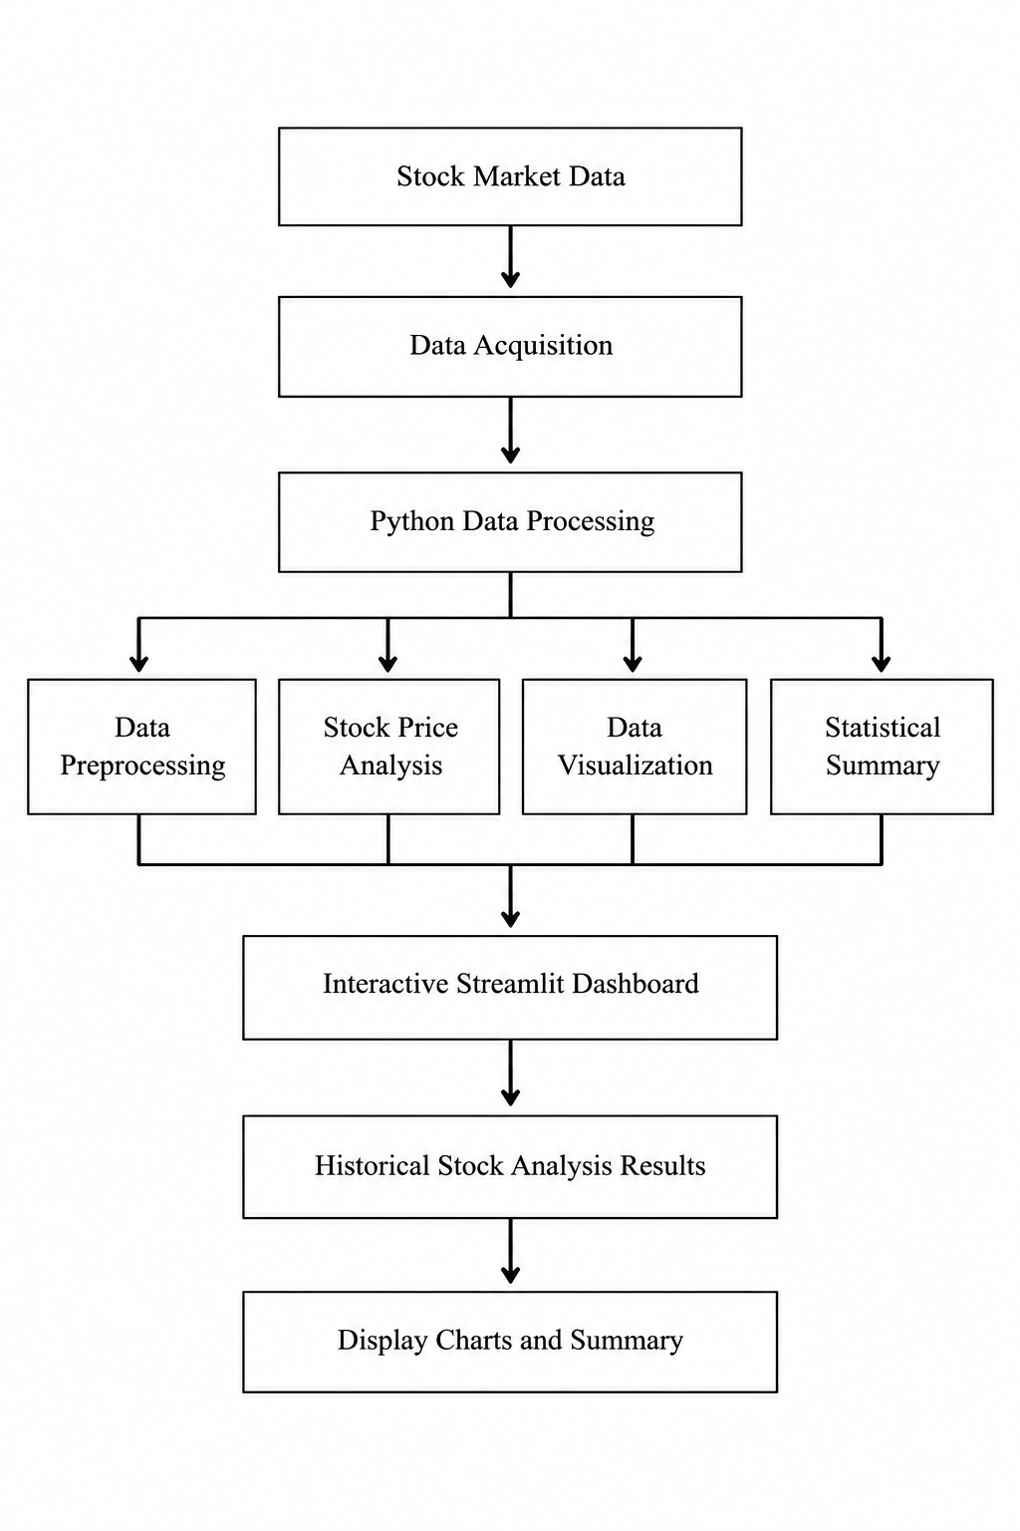

CHAPTER 7: RESULT ANALYSIS

7.1 Introduction
- The result-analysis phase evaluates whether the STOCKTRACK – Stock Data Analyzer and Visualizer Using Streamlit application performs according to its intended objectives. After implementation, the application should be tested using suitable historical stock market datasets to verify its data-processing capabilities, analytical calculations, visualization features, and dashboard functionality.
- The main purpose of this phase is to determine whether the system can collect or load stock market data, process the information correctly, analyze historical price movements, and present the results in an understandable format. The analysis also helps identify errors and areas that may require improvement.

The analysis should focus on:
- Functionality
- Accuracy
- Reliability
- Test completion
- Trust Score generation
- User understanding
- Module integration

7.2 RESULTS OBTAINED

The results section describes the outputs produced by the STOCKTRACK application during testing. The actual results depend on the dataset used, the features implemented, and the tests performed.

When supplied with a valid historical stock market dataset, the application is designed to process stock information and present it through charts, tables, and numerical summaries. Users can examine historical price movements and review the available statistical information.

The following table provides an example of how the results can be documented after testing.
Test Module | Expected Result | Status
Application Launch | Dashboard opens successfully | To be tested
Data Acquisition | Stock data is loaded successfully | To be tested
Data Preprocessing | Data is cleaned and organized correctly | To be tested
Stock Price Analysis | Required price statistics are calculated correctly | To be tested
Price Visualization | Historical stock price chart is displayed | To be tested

The expected output of STOCKTRACK includes historical stock price charts, relevant price statistics, and trading volume visualizations where supported. These outputs help users understand historical market behaviour without manually examining every data record.

7.3 PERFORMANCE ANALYSIS

Performance analysis evaluates how effectively STOCKTRACK processes stock market data and presents the results. Different performance measures can be used to understand the application's speed, correctness, reliability, and ease of use.

7.3.1 Response Time

Response time refers to the time required for the application to load the selected dataset, process the information, generate visualizations, and display the final results.

It can be measured using a stopwatch or programmatically using Python's time-measurement functions. Testing should be conducted with datasets of different sizes to understand how processing time changes as the amount of data increases.

Response Time = Completion Time − Start Time

A shorter response time generally indicates that the application processes the selected data more efficiently.

7.3.2 Data Accuracy

Data accuracy measures whether the values displayed by STOCKTRACK match the original dataset and the expected calculated results.

For example, the opening price, closing price, highest price, and lowest price displayed by the application can be compared with the corresponding records in the source dataset. Calculated values, such as price differences or percentage changes, should also be checked manually or using an independent calculation.

This test helps identify incorrect calculations, data conversion errors, and problems caused by missing or invalid values.

7.3.3 Reliability

Reliability refers to the application's ability to process data and produce consistent results during repeated tests.

The same dataset can be loaded multiple times to check whether the calculated statistics and generated visualizations remain consistent. Additional tests can be performed with different datasets to verify whether the application handles variations in data format and size appropriately.

7.3.4 Usability

Usability analysis determines whether users can operate the STOCKTRACK dashboard easily.

The dashboard can be evaluated based on the clarity of its labels, organization of charts, visibility of important statistics, and ease of interaction. Users may be asked to select a stock, examine a chart, and identify its highest or closing price.

Feedback can help identify areas where the interface or presentation of results could be improved.

7.3.5 Module Completion Rate

The module completion rate indicates the percentage of planned tests or operations that finish successfully.

It can be calculated using the following formula:

Module Completion Rate (%) = (Number of Successfully Completed Tests / Total Number of Planned Tests) × 100

For example, if 9 out of 10 planned tests complete successfully:

Module Completion Rate = (9 / 10) × 100

Module Completion Rate = 90%

This example is illustrative only. The actual value should be calculated using the results of completed tests.

7.4 ACCURACY ANALYSIS

Accuracy analysis is performed to verify whether STOCKTRACK correctly processes the stock market information and generates valid analytical results.

The accuracy of the application can be evaluated by comparing its output with the original dataset and independently verified calculations. The comparison should cover both the values displayed directly from the dataset and any statistics calculated by the application.

The calculated value can then be compared with the value displayed by STOCKTRACK.

The accuracy of individual test results can be calculated as follows:

Accuracy (%) = (Number of Correct Results / Total Number of Verified Results) × 100

Example only:

If STOCKTRACK produces 18 correct results out of 20 verified checks:

Accuracy = (18 / 20) × 100

Accuracy = 90%

7.5 USER FEEDBACK ANALYSIS

User feedback analysis helps determine whether STOCKTRACK provides a useful and understandable way to explore historical stock market data.

A small survey can be conducted among students or other users who are interested in learning about stock market analysis. Participants can be asked to use the dashboard and provide feedback about its ease of use, chart readability, and usefulness of the displayed statistics.

The survey may include the following questions:

Have you ever viewed or analyzed stock market data?

What is the biggest difficulty you face when understanding stock prices?

Do you find historical stock price charts useful?

Is it easy to understand the information displayed on the STOCKTRACK dashboard?

Are the charts and numerical summaries clearly presented?

Would you use an interactive dashboard to explore historical stock market data?

Which additional features would you like to see in the application?

7.6 LIMITATIONS

Although STOCKTRACK provides a convenient platform for historical stock data analysis, it has certain limitations that should be considered.

Data Availability: The application depends on the availability and quality of the configured stock data source or uploaded dataset.

Historical Data Focus: The application mainly supports analysis of historical information and may not provide real-time market updates unless that feature is implemented.

Data Quality: Missing values, incorrect records, or inconsistent formats in the source dataset may affect the analysis.

Internet Dependency: Online data retrieval requires a suitable internet connection. Offline analysis may be possible when local datasets are supported.

Visualization Limitations: The types of charts and analytical views available depend on the features implemented in the application.

Processing Performance: Very large datasets may require additional memory and processing time.

Technical Indicators: Indicators such as moving averages or other advanced measures are available only if they have been implemented.

7.7 SUMMARY

This chapter presented the result-analysis process for the STOCKTRACK application. It described the evaluation of data acquisition, preprocessing, stock price calculations, visualization, dashboard interaction, and result generation.

Performance can be assessed through response time, data accuracy, reliability, usability, and module completion rate. Accuracy can be verified by comparing the application's output with the original dataset and independently calculated values. User feedback can provide additional information about the clarity and usefulness of the dashboard.

Overall, the result-analysis process provides a structured way to determine whether STOCKTRACK meets its objectives and identifies areas for improvement in future versions.

CHAPTER 8: CONCLUSION AND FUTURE WORK

8.1 CONCLUSION
STOCKTRACK – Stock Data Analyzer and Visualizer Using Streamlit is developed as a simple and interactive solution for analyzing and visualizing historical stock market data. The system combines important functions such as stock data acquisition, data preprocessing, stock price analysis, graphical visualization, and statistical summary generation into a single web-based application. By using Python and Streamlit, STOCKTRACK allows users to explore historical stock prices, understand price movements, examine trading volume, and view important stock market information through charts and an interactive dashboard. Instead of manually analyzing large datasets or switching between multiple tools, users can access the available information in an organized and understandable format. The application processes stock data and presents relevant results, such as opening prices, closing prices, highest and lowest prices, and other calculated statistics supported by the implementation. The main purpose of STOCKTRACK is to simplify historical stock market analysis and help users understand past market performance; it does not guarantee future stock prices or investment returns. Overall, STOCKTRACK demonstrates how Python programming, data analysis libraries, and interactive web technologies can be combined to address the practical challenge of understanding stock market data.
8.2 FUTURE ENHANCEMENTS
STOCKTRACK can be improved in several ways to increase its analytical capabilities and usability. In future versions, real-time stock market data integration can be introduced to allow users to monitor market movements using updated information from a suitable data provider. Advanced technical indicators, such as moving averages, the Relative Strength Index (RSI), and Moving Average Convergence Divergence (MACD), can be added to provide more detailed analysis of historical price trends.

CHAPTER-09

INDIVIDUAL TEAM MEMBERS REPORT

9.1 CONTRIBUTION OF TEAM MEMBERS

DEEKSHITH.A (24CU0310225)
Contribution:
Worked on the overall system design and development of STOCKTRACK – Stock Data Analyzer and Visualizer Using Streamlit. Responsible for Python programming, stock market data collection, data preprocessing, stock price analysis, graphical visualization, and dashboard development. Contributed to integrating the different modules, testing the application, and presenting historical stock market data through interactive charts and statistical summaries.

ABDUR RAHMAN.A (24CU0310228)
Contribution:
Worked on the software development of STOCKTRACK – Stock Data Analyzer and Visualizer Using Streamlit, including Python-based application development, stock market data processing, analytical calculations, interactive dashboard design, graphical visualization, and integration of the different modules.

MUGUNDHAN.A (24CU0310243)
Contribution:
Worked on testing and validating STOCKTRACK features, collecting stock data, verifying analytical results, and ensuring the accuracy of charts and dashboard outputs,and also done the report document.
.

APPENDIX-1: SCREENSHOTS & OUTPUTS
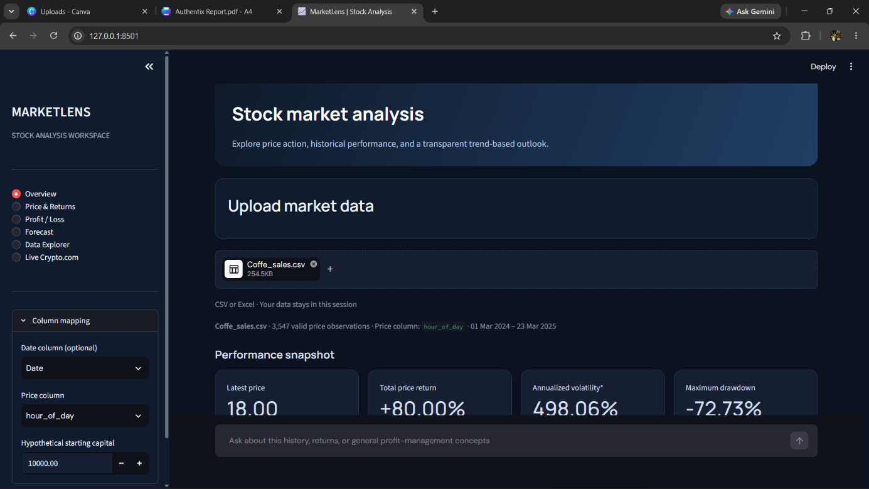

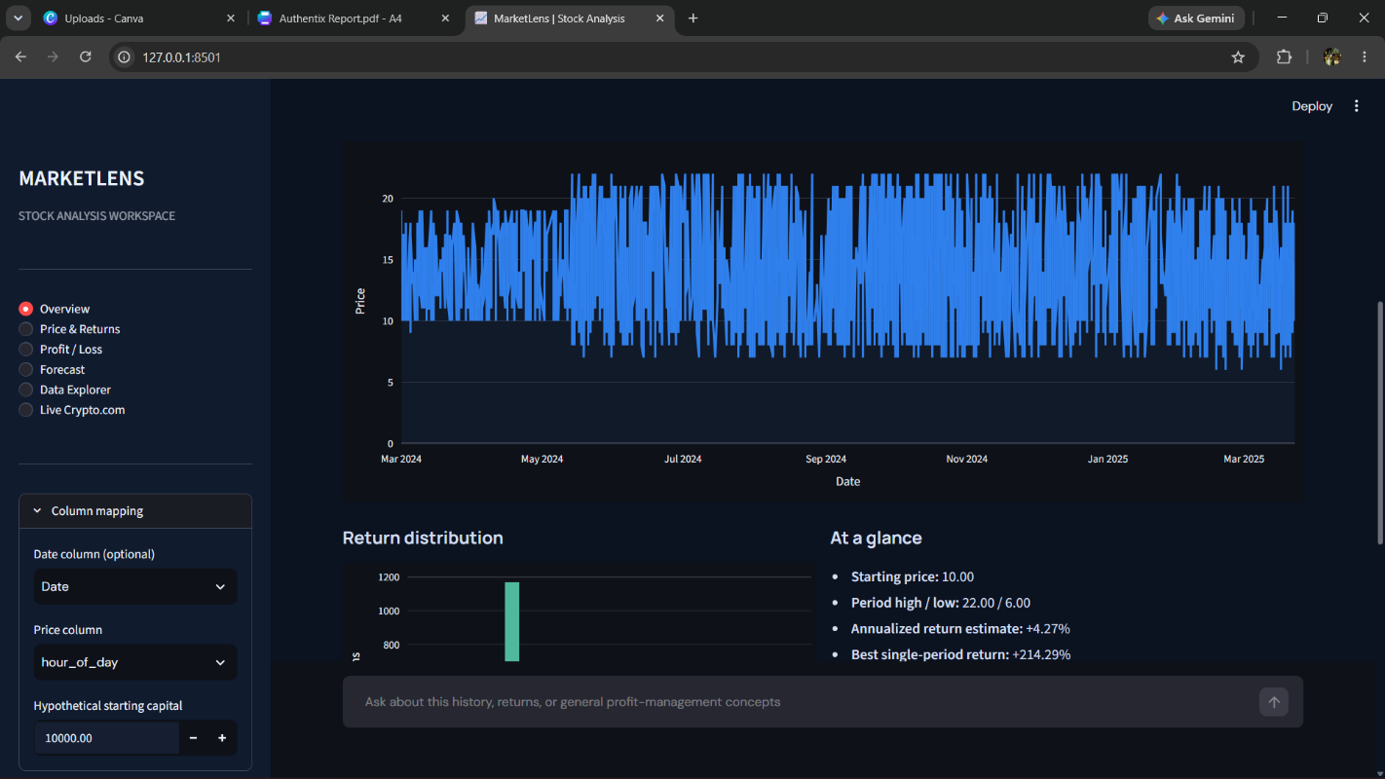

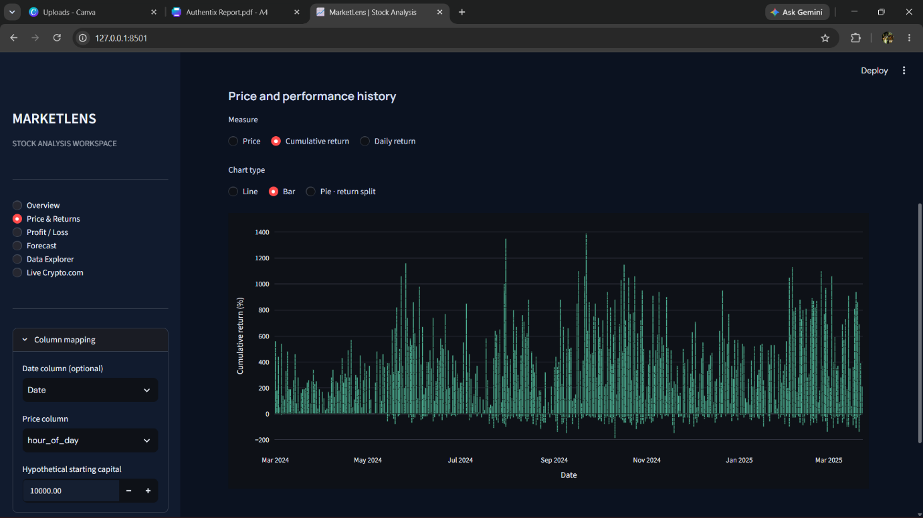
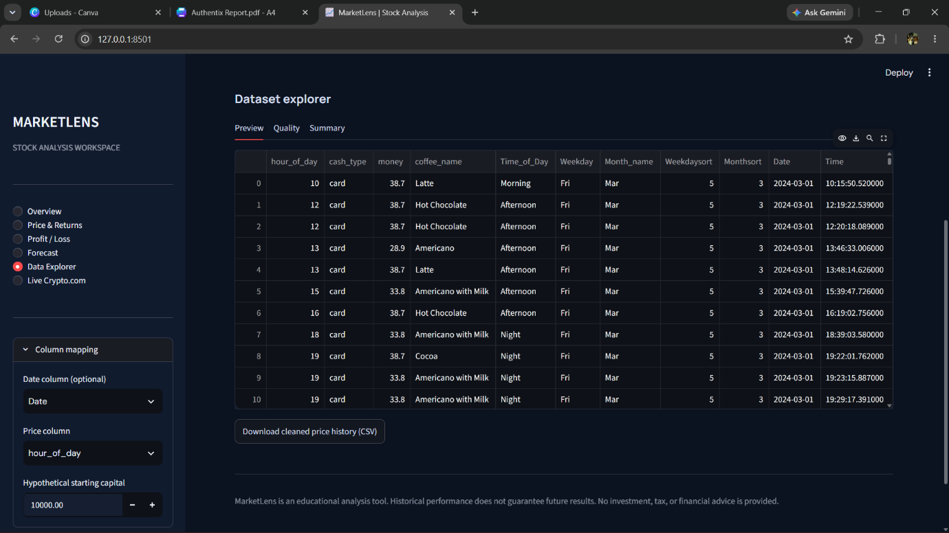

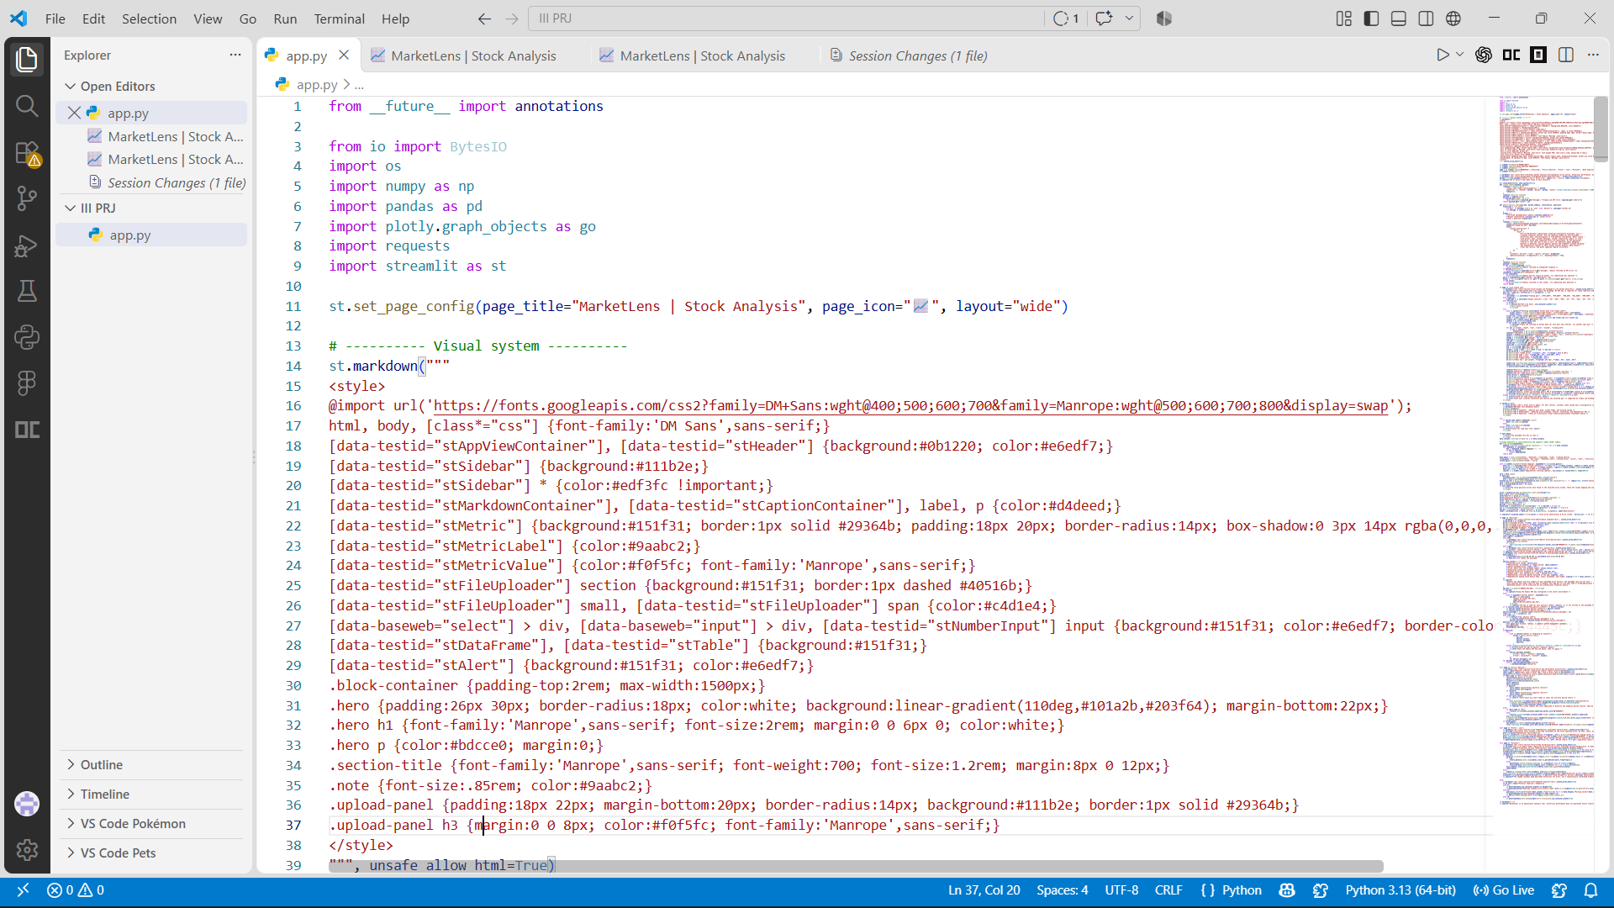
CODES
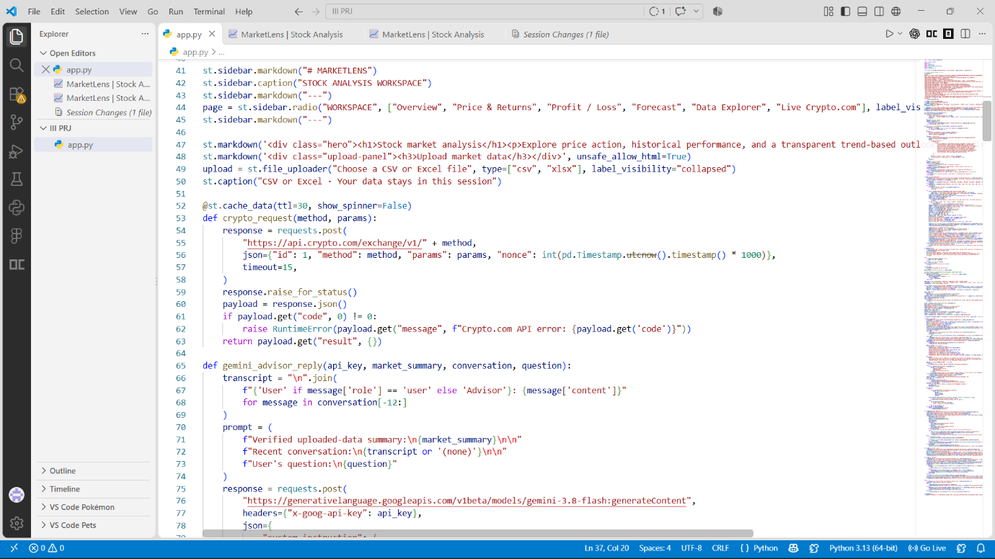

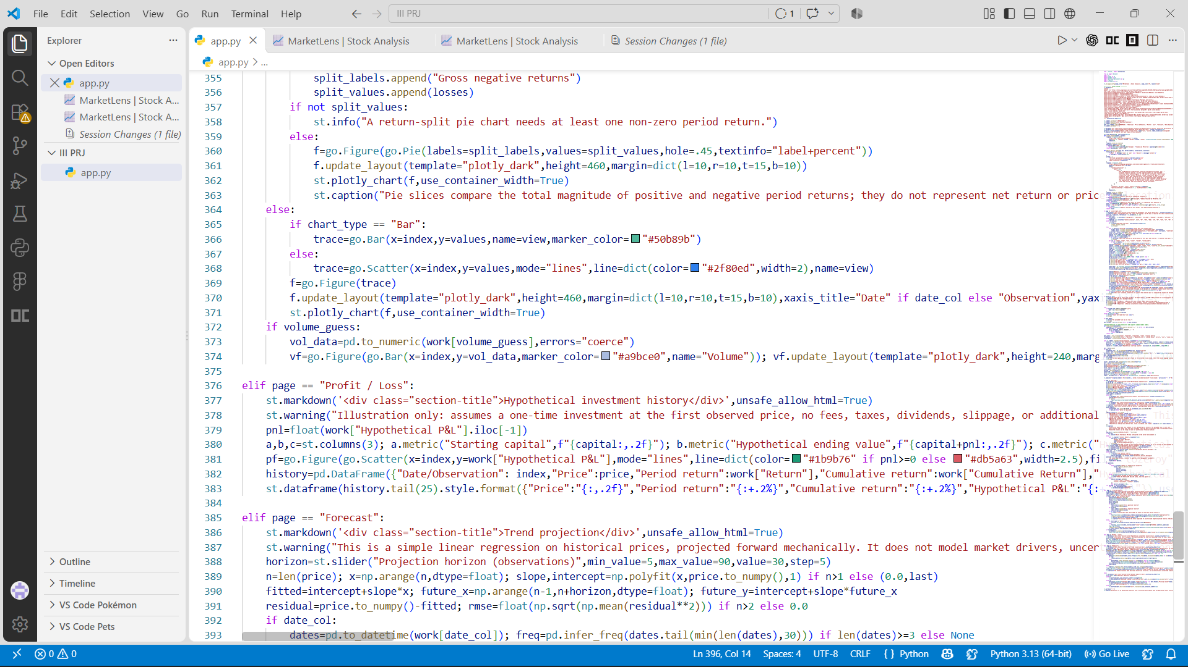
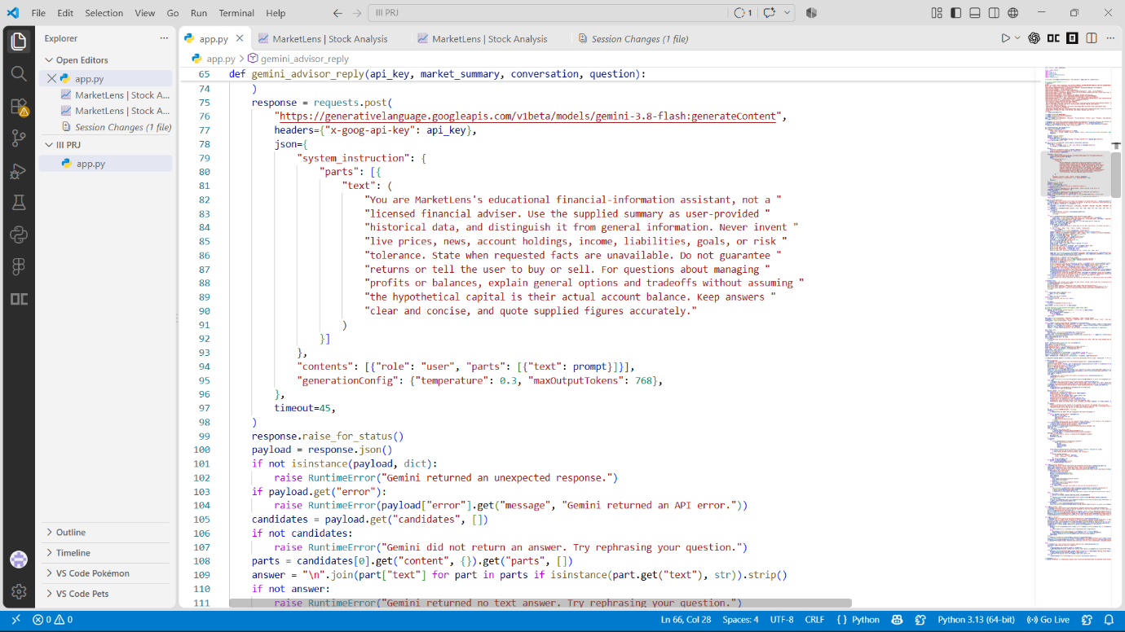

APPENDIX 3 : TEAMDETAILS
SUPERVISOR: Mr.V.Jothi Prasad, Assistant Professor (SG), CSE
TEAM MEMBERS:

DEEKSHITH.A
(24CU0310225)
ABDUR RAHMAN.A
(24CU0310228)
MUGUNDHAN.A
(24CU0310243)

